ACTIVITY BASED LEARNING

NAME: VELIVENTI LASYA PRIYA
ROLL NUM:26000069
BRANCH:CSE
SECTION:01
YEAR:2026-30

CASE STUDY-08: ONLINE FOOD ORDERING WEBSITE
Design a food ordering interface with restaurant details, menu categories, food images, prices, special offers, customer reviews, and order buttons. Use card layouts, attractive backgrounds, and mobile-friendly navigation
Explanation:
The Online Food Ordering Website provides an attractive interface for exploring food items and restaurant information. It displays food images, menu categories, prices, special offers, and customer reviews. The website uses card layouts, warm colors, and responsive navigation to make browsing food items convenient on desktop and mobile devices.
HTML TAGS USED
Tag | Purpose
<html> | Defines the HTML document.
<head> | Contains metadata, the page title, and the CSS link.
<title> | Specifies the website title shown in the browser tab.
<link> | Connects the external CSS stylesheet.
<body> | Contains the visible website content.
<header> | Displays the restaurant name and tagline.
<nav> | Provides navigation links to menu, offers, and reviews.
<a> | Creates navigation links and order buttons.
<section> | Separates the menu, offers, categories, and reviews.
<h1>, <h2>, <h3>, <h4> | Display headings and food item names or prices.
<p> | Displays food descriptions and restaurant details.
<div> | Groups food cards, categories, and review panels.
<img> | Displays food photographs.
<footer> | Displays contact information and copyright details.

CSS TAGS USED
. background – Adds attractive background colors.
. color – Sets text colors.
.font-family – Defines the text font.
. display: flex – Arranges food cards in rows.
. flex-wrap – Moves cards to the next line when necessary.
. gap – Adds space between food cards.
.width and height – Set card and image dimensions.
.object-fit: cover – Fits images into their containers without stretching them.
. border-radius – Gives cards rounded corners.
. box-shadow – Creates depth around food cards.
.hover – Changes an element's appearance when the pointer moves over it.
.media – Makes the website responsive on mobile devices.
Screenshots:
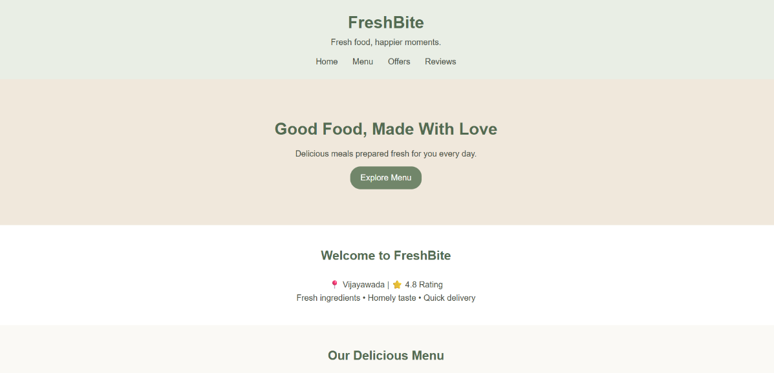

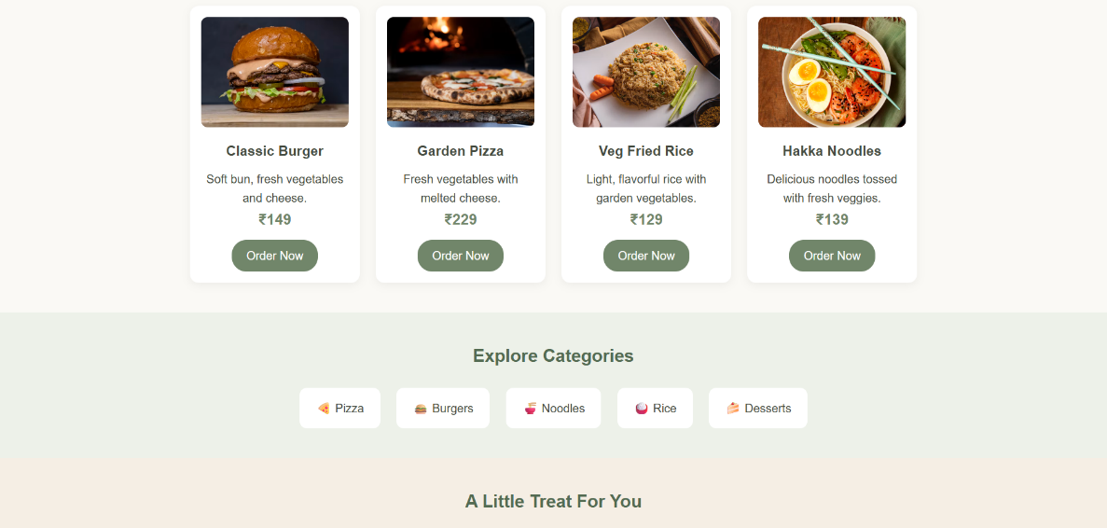

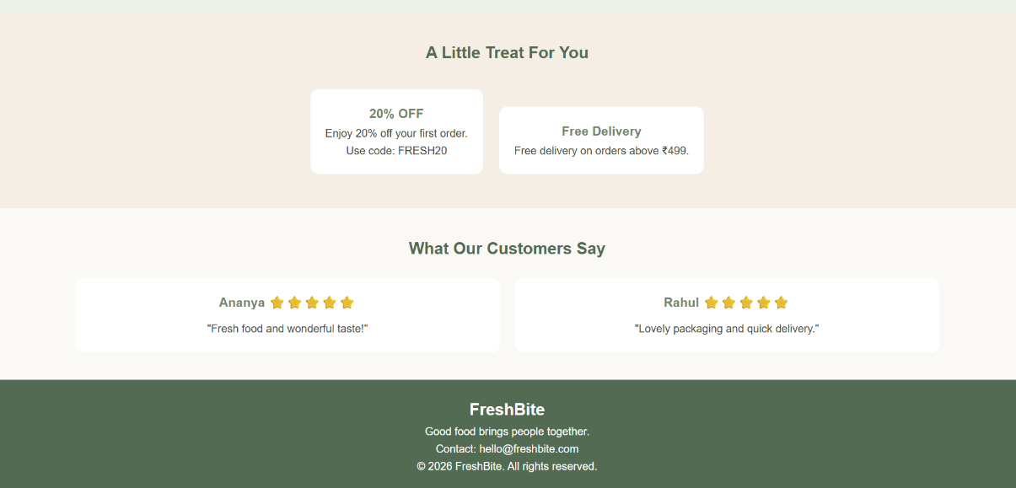
CASE STUDY 15: YOGA AND MEDITATION
Create a wellness website featuring yoga poses, meditation techniques, instructor profiles, class schedules, membership plans, and wellness articles. Use calming colors, readable typography, and responsive image sections.

Explanation:
The Yoga and Meditation Website is designed to promote physical fitness, mental relaxation, and a healthy lifestyle. It provides information about yoga poses, meditation techniques, instructor profiles, class schedules, membership plans, and wellness articles. The website uses calming colors, attractive images, and a responsive layout to create a peaceful and user-friendly experience.

HTML TAGS USED:
Tag | Purpose
<html> | Defines the root of the HTML document.
<head> | Contains the page title and stylesheet link.
<title> | Specifies the title displayed in the browser tab.
<link> | Connects the HTML file to the CSS file.
<body> | Contains all the visible website content.
<header> | Displays the website name and introductory information.
<nav> | Contains navigation links to different sections.
<a> | Creates hyperlinks and navigation buttons.
<section> | Organizes content into different sections.
<h1>, <h2>, <h3> | Display headings of different levels.
<p> | Displays paragraphs and descriptions.
<div> | Groups elements for styling and layout.
<img> | Displays images of yoga poses and activities.
<table> | Displays the weekly class schedule.
<tr> | Defines a table row.
<th> | Defines a table heading cell.
<td> | Defines a table data cell.
<footer> | Displays contact details and copyright information.

CSS TAGS USED:
. color – Changes the text color.
. background – Adds background colors to sections.
. font-family – Sets the font style.
. padding and margin – Control spacing around elements.
. display: flex – Arranges cards in a flexible layout.
. border-radius – Creates rounded corners.
. box-shadow – Adds subtle shadows to cards.
. media – Adjusts the layout for smaller screens.

Screenshots:
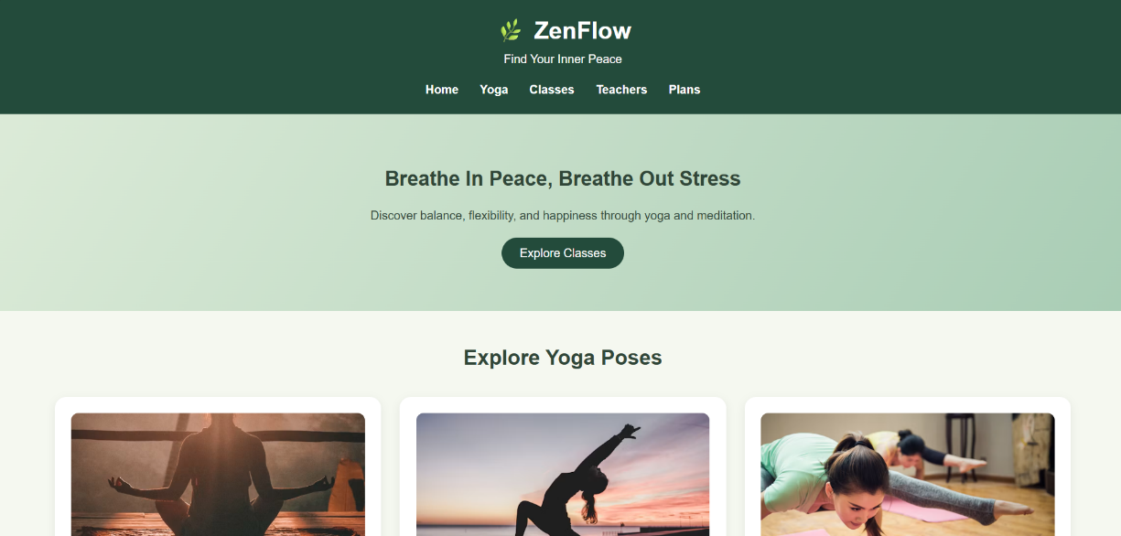
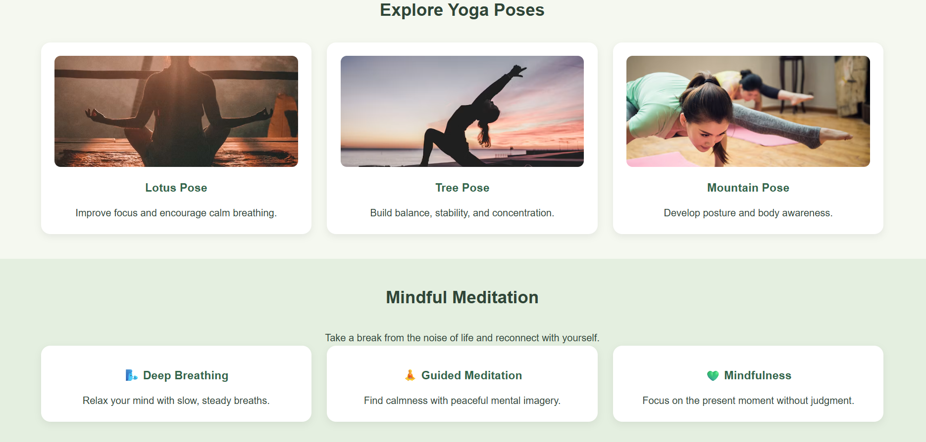
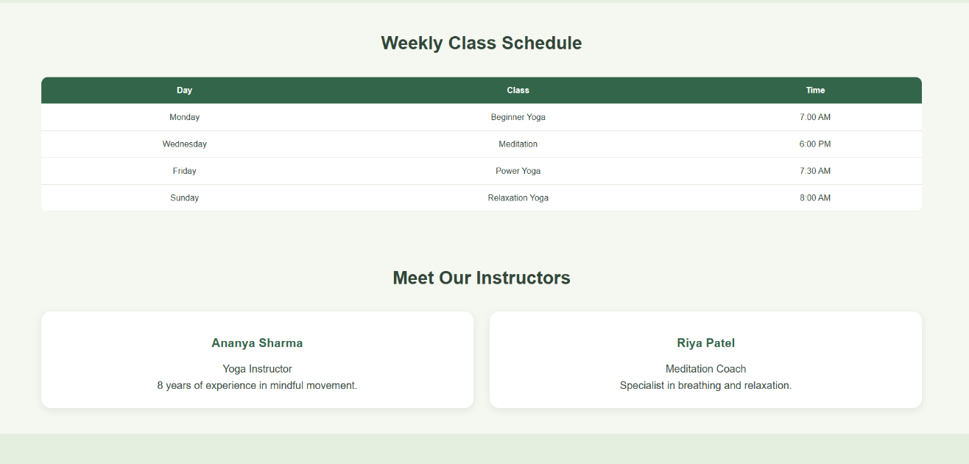
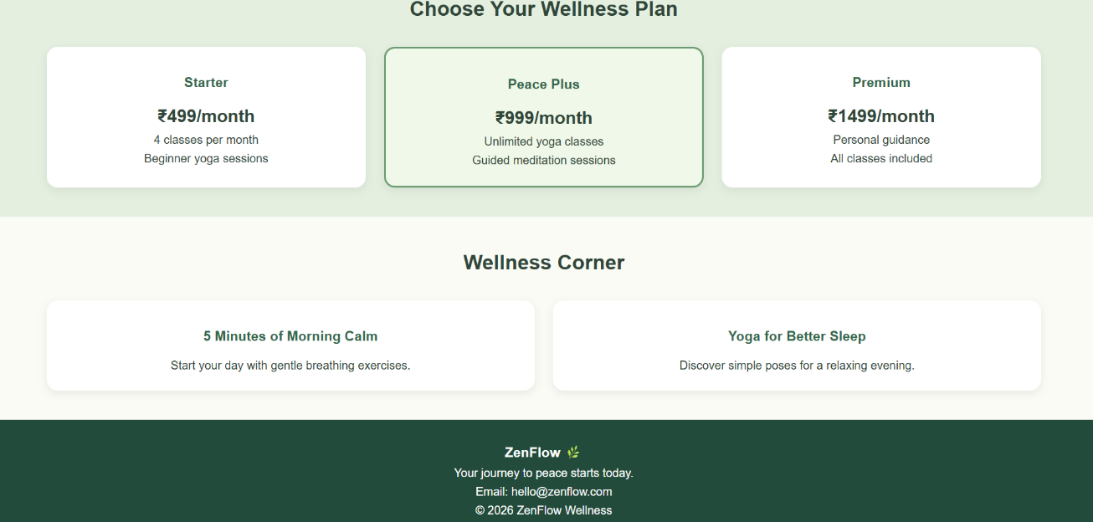
CASE STUDY 19: ADVENTURE AND TREKKING WEBSITE
Build a website showcasing trekking routes, camping trips, difficulty levels, trip schedules, equipment checklists, safety guidelines, and package prices. Use image overlays and visually distinct information panels.

Explanation:
The Adventure and Trekking Website is designed for people interested in outdoor activities, mountain trekking, and camping trips. It showcases trekking routes, difficulty levels, trip durations, camping options, package prices, upcoming schedules, equipment checklists, and safety guidelines. The website uses scenic images, image overlays, and visually distinct information panels to create an engaging adventure-themed experience.

HTML tags used:
Tag | Purpose
<html> | Defines the HTML document.
<head> | Contains the page title and stylesheet link.
<title> | Specifies the title displayed in the browser tab.
<link> | Connects the HTML file to the CSS stylesheet.
<body> | Contains all visible website content.
<header> | Displays the website name and tagline.
<nav> | Provides navigation links to different sections.
<a> | Creates hyperlinks and the adventure button.
<section> | Organizes trekking, camping, packages, schedules, and safety information.
<h1>, <h2>, <h3> | Display the website title and section headings.
<p> | Displays route details, prices, and safety guidelines.
<div> | Groups trekking cards, package panels, and checklists.
<img> | Displays mountain, forest, and trekking photographs.
<table> | Presents the upcoming trip schedule.
<tr> | Defines rows in the schedule table.
<th> | Defines the schedule's column headings.
<td> | Displays trip names, dates, and difficulty levels.
<footer> | Displays contact information and copyright details.
CSS tags used:
- background-color – Applies different colors to website sections.
- background-image – Adds a scenic background image to the hero section.
- linear-gradient() – Creates a dark overlay over the background image to improve text readability.
- background-size: cover – Ensures the background image covers the hero area.
- background-position: center – Centers the background image.
- display: flex – Arranges trekking cards and package panels.
- flex-wrap – Allows cards to move to the next line on smaller screens.
- border-radius – Creates rounded cards and buttons.
- box-shadow – Adds subtle shadows to information panels.
- border-collapse – Removes double borders from the schedule table.
- media – Adjusts the website layout for mobile screens.

Screenshots:
